Examining issues related to PV generator components
Grasshope (hope.zh@gmail.com)
Aug 2018

- Original objectives
- Define shading surface as PV generator object in EnergyPlus through LB+HB
- get the following Building electricity usage and PV electricity production related output variables for data analysis:

Output:Variable,*,Generator Produced DC Electric Power, hourly;
Output:Variable,*,Generator Produced DC Electric Energy, hourly;
Output:Variable,*,Generator PV Array Efficiency, hourly;
Output:Variable,*,Generator PV Cell Temperature, hourly;
Output:Variable,*,Facility Total Surplus Electric Energy, hourly;
Output:Variable,*,Facility Total Purchased Electric Energy, hourly;
Output:Variable,*,Facility Total Produced Electric Energy, hourly;
Output:Variable,*,Facility Net Purchased Electric Energy, hourly;
Output:Variable,*,Facility Total Building Electric Demand Power, hourly;
Output:Variable,*,Facility Total Building Electric Demand Energy, hourly;
Output:Variable,*,Facility Total HVAC Electric Demand Power, hourly;
Output:Variable,*,Facility Total HVAC Electric Demand Energy, hourly;
Output:Variable,*,Facility Total Electric Demand Power, hourly;
Output:Variable,*,Facility Total Electric Demand Energy, hourly;
Output:Meter, Electricity:Building, hourly;
Output:Meter, ElectricityNet:Facility, hourly;
Output:Meter, ElectricityPurchased:Facility, hourly;

- Test model
- A simple model was created for the test which includes a small building with three thermal zones in different shapes and volumes. Three shading surfaces detached from the roofs were defined as PV surfaces.
- Default settings on building program and constructions are used.
- Chicago’s epw file was used to get both cooling and heating loads.

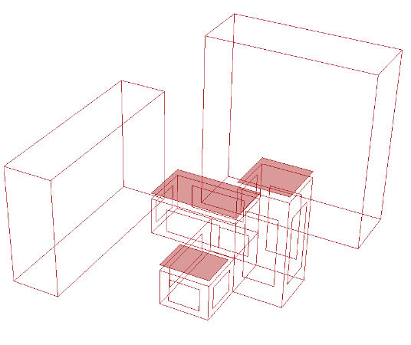
- Tests
Different combinations of the old and new versions of the following components were tested using the same building model. In total seven scenarios were tested.

Component | Old version | New version
Ladybug | V0066, JUN-02-2018 | V0066 JUL-11-2018
Honeybee | V0063, JAN-20-2018 | V0063 JUN-29-2018
PVgen | V0063, JAN-20-2018 | V0063, MAR-08-2018
generationSystem | V0062, JUL-28-2017 | V0063, JAN-20-2018
runEnergySimulation | V0063, JAN-20-2018 | v0063, JUL-24-2018
exportToOpenStudio |  | V0063, AUG-08-2018
EnergyPlus | V8.8.0

Compatibility between the components and main issues are summarized in the table below.

Compatibility |  | Old |  | New
 |  | Ladybug  V0066  JUN-02-2018 | Honeybee  V0063  JAN-20-2018 | Ladybug  V0066  JUL-11-2018 | Honeybee  V0063  JUN-29-2018
Old | PVgen  V0063  JAN-20-2018 | Yes |  | Error  - The length of a list of inputs is longer than the number of Honeybee surfaces connected to this component!
 | generationSystem  V0062  JUL-28-2017 | Yes
 | runEnergySimulation  V0063  JAN-20-2018 | Yes |  | Error  - Solution exception:'PV_gen' object has no attribute 'surfacename'
New | PVgen  V0063  MAR-08-2018 | Error  - Solution exception:__init__() takes exactly 12 arguments (8 given) |  | Error  - The length of a list of inputs is longer than the number of Honeybee surfaces connected to this component!
 | generationSystem  V0063  JAN-20-2018 | Yes |  | Yes
 | runEnergySimulation  v0063  JUL-24-2018 | No  (got reminder to update HB) |  | Error  - Solution exception:'PV_gen' object has no attribute 'surfacename'
 | exportToOpenStudio  V0063  AUG-08-2018 |  |  | Yes

- Results

- Combination A (Scenario 1) using the older version of the components generates the requested output variables correctly. (see result of Scenario 1 on page 5)
Compatibility |  | Old |  | New
 |  | Ladybug  V0066  JUN-02-2018 | Honeybee  V0063  JAN-20-2018 | Ladybug  V0066  JUL-11-2018 | Honeybee  V0063  JUN-29-2018
Old | PVgen  V0063  JAN-20-2018 | Yes |  | Error  - The length of a list of inputs is longer than the number of Honeybee surfaces connected to this component!
 | generationSystem  V0062  JUL-28-2017 | Yes
 | runEnergySimulation  V0063  JAN-20-2018 | Yes |  | Error  - Solution exception:'PV_gen' object has no attribute 'surfacename'
New | PVgen  V0063  MAR-08-2018 | Error  - Solution exception:__init__() takes exactly 12 arguments (8 given) |  | Error  - The length of a list of inputs is longer than the number of Honeybee surfaces connected to this component!
 | generationSystem  V0063  JAN-20-2018 | Yes |  | Yes
 | runEnergySimulation  v0063  JUL-24-2018 | No  (got reminder to update HB) |  | Error  - Solution exception:'PV_gen' object has no attribute 'surfacename'
 | exportToOpenStudio  V0063  AUG-08-2018 |  |  | Yes

- Combination B (Scenario 7) using the latest version of the components works only when the code of PVgen is revised in two places to suppress the error output of “-1”.
- A few of the key output variables requested were missing. (see result of Scenario 7 on page 13)
Compatibility |  | Old |  | New
 |  | Ladybug  V0066  JUN-02-2018 | Honeybee  V0063  JAN-20-2018 | Ladybug  V0066  JUL-11-2018 | Honeybee  V0063  JUN-29-2018
Old | PVgen  V0063  JAN-20-2018 | Yes |  | Error  - The length of a list of inputs is longer than the number of Honeybee surfaces connected to this component!
 | generationSystem  V0062  JUL-28-2017 | Yes
 | runEnergySimulation  V0063  JAN-20-2018 | Yes |  | Error  - Solution exception:'PV_gen' object has no attribute 'surfacename'
New | PVgen  V0063  MAR-08-2018 | Error  - Solution exception:__init__() takes exactly 12 arguments (8 given) |  | Error  - The length of a list of inputs is longer than the number of Honeybee surfaces connected to this component!
 | generationSystem  V0063  JAN-20-2018 | Yes |  | Yes
 | runEnergySimulation  v0063  JUL-24-2018 | No  (got reminder to update HB) |  | Error  - Solution exception:'PV_gen' object has no attribute 'surfacename'
 | exportToOpenStudio  V0063  AUG-08-2018 |  |  | Yes

Assuming the result of combination A is correct, the result on PV electricity yield for combination B is overestimated by 30.1%. (note the difference in energy unit)

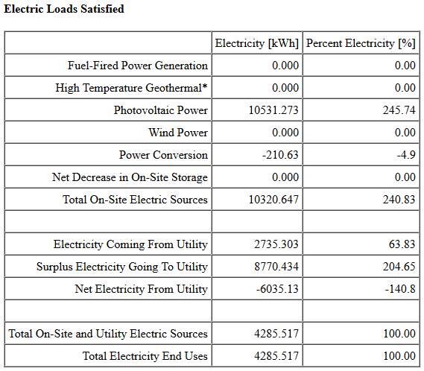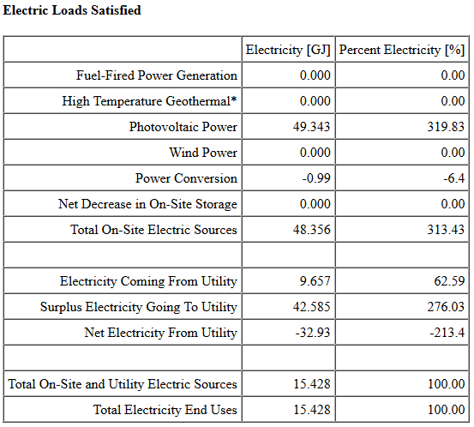
Result of combination A Result of combination B

For combination B, electricity usage is about the same. But cooling loads is overestimated by 7.2%, and heating loads is slightly underestimated by only -0.3%.

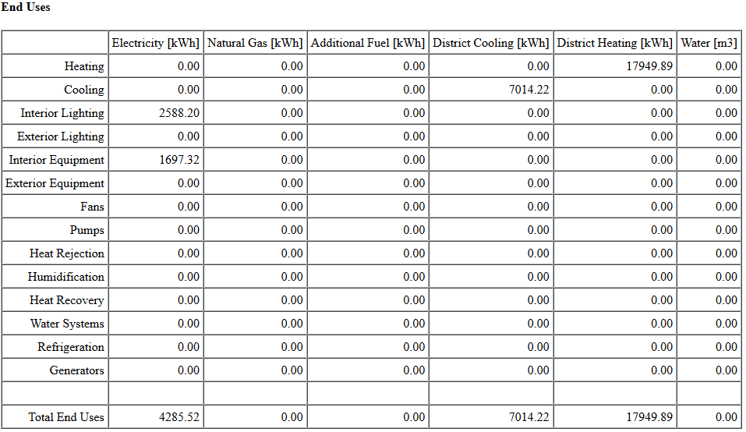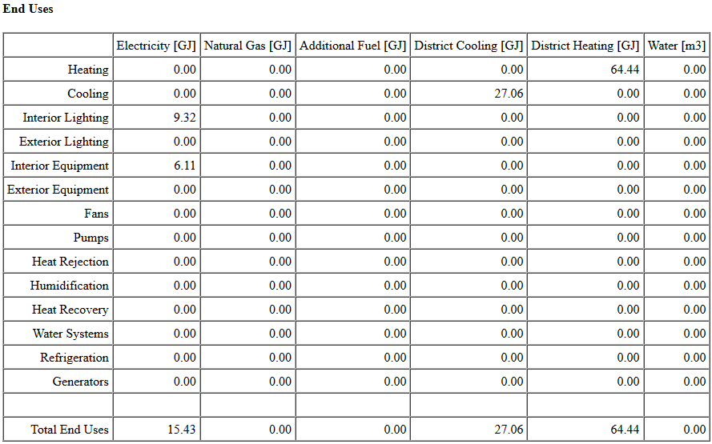
Result of combination A Result of combination B

Without PV, the difference in electricity usage, cooling and heating loads between combination A and B is very small and could be regarded as zero.

The outcome of the seven scenarios tested are shown below.

Scenario 1 (S1) : test_PVgen_s1.gh

Compatibility |  | Old |  | New
 |  | Ladybug  V0066  JUN-02-2018 | Honeybee  V0063  JAN-20-2018 | Ladybug  V0066  JUL-11-2018 | Honeybee  V0063  JUN-29-2018
Old | PVgen  V0063  JAN-20-2018 | Yes |  | Error  The length of a list of inputs is longer than the number of Honeybee surfaces connected to this component!
 | generationSystem  V0062  JUL-28-2017 | Yes
 | runEnergySimulation  V0063  JAN-20-2018 | Yes |  | Error  - Solution exception:'PV_gen' object has no attribute 'surfacename'
New | PVgen  V0063  MAR-08-2018 | Error  - Solution exception:__init__() takes exactly 12 arguments (8 given) |  | Error  - The length of a list of inputs is longer than the number of Honeybee surfaces connected to this component!
 | generationSystem  V0063  JAN-20-2018 | Yes |  | Yes
 | runEnergySimulation  v0063  JUL-24-2018 | No  (got reminder to update HB) |  | Error  - Solution exception:'PV_gen' object has no attribute 'surfacename'
 | exportToOpenStudio  V0063  AUG-08-2018 |  |  | Yes

Results (correct):
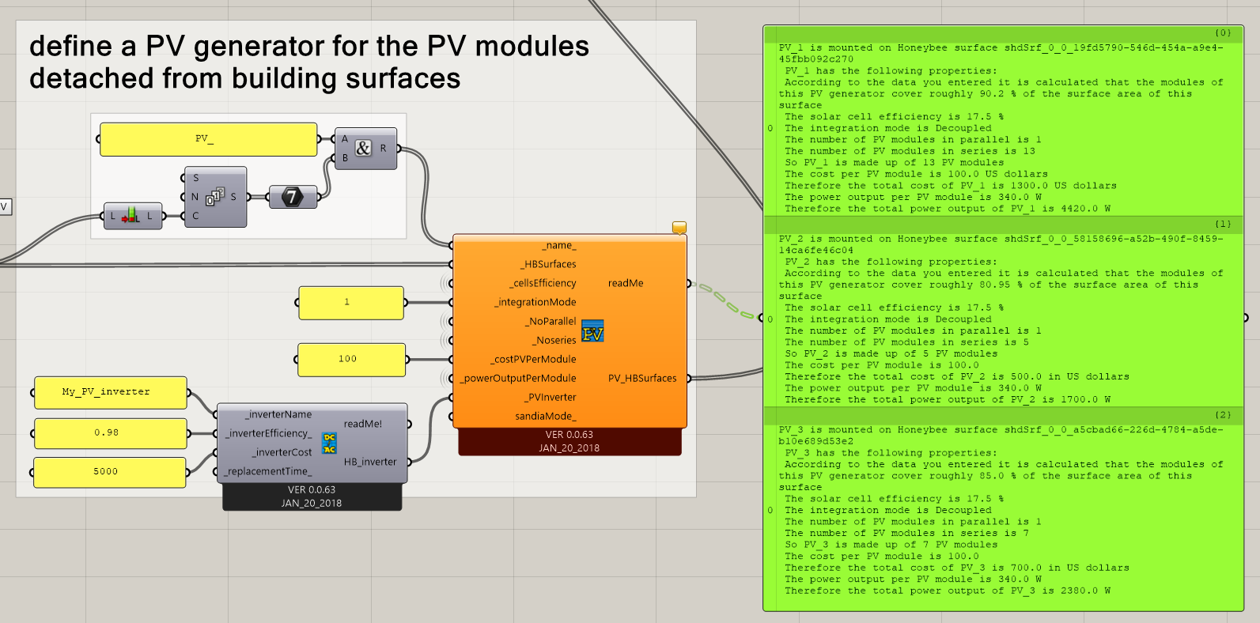

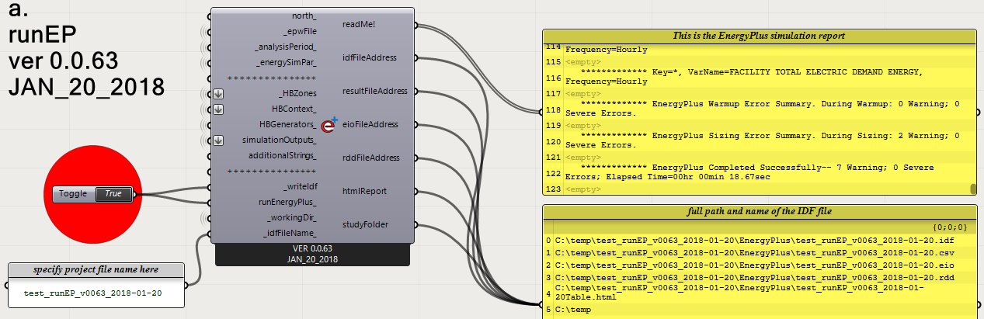
End Uses (as reported in the html file generated)
 | Electricity [kWh] | Natural Gas [kWh] | Additional Fuel [kWh] | District Cooling [kWh] | District Heating [kWh] | Water [m3]
Heating | 0.00 | 0.00 | 0.00 | 0.00 | 17949.89 | 0.00
Cooling | 0.00 | 0.00 | 0.00 | 7014.22 | 0.00 | 0.00
Interior Lighting | 2588.20 | 0.00 | 0.00 | 0.00 | 0.00 | 0.00
Exterior Lighting | 0.00 | 0.00 | 0.00 | 0.00 | 0.00 | 0.00
Interior Equipment | 1697.32 | 0.00 | 0.00 | 0.00 | 0.00 | 0.00
… | … | … | … | … | … | …
Total End Uses | 4285.52 | 0.00 | 0.00 | 7014.22 | 17949.89 | 0.00

Electric Loads Satisfied (as reported in the html file generated)
 | Electricity [kWh] | Percent Electricity [%]
Fuel-Fired Power Generation | 0.000 | 0.00
High Temperature Geothermal* | 0.000 | 0.00
Photovoltaic Power | 10531.273 | 245.74
Wind Power | 0.000 | 0.00
Power Conversion | -210.63 | -4.9
Net Decrease in On-Site Storage | 0.000 | 0.00
Total On-Site Electric Sources | 10320.647 | 240.83
Electricity Coming From Utility | 2735.303 | 63.83
Surplus Electricity Going To Utility | 8770.434 | 204.65
Net Electricity From Utility | -6035.13 | -140.8
Total On-Site and Utility Electric Sources | 4285.517 | 100.00
Total Electricity End Uses | 4285.517 | 100.00

Scenario 2 (S2) : test_PVgen_s2.gh

generationSystem component is replaced with the latest version.
Compatibility |  | Old |  | New
 |  | Ladybug  V0066  JUN-02-2018 | Honeybee  V0063  JAN-20-2018 | Ladybug  V0066  JUL-11-2018 | Honeybee  V0063  JUN-29-2018
Old | PVgen  V0063  JAN-20-2018 | Yes |  | Error  The length of a list of inputs is longer than the number of Honeybee surfaces connected to this component!
 | generationSystem  V0062  JUL-28-2017 | Yes
 | runEnergySimulation  V0063  JAN-20-2018 | Yes |  | Error  - Solution exception:'PV_gen' object has no attribute 'surfacename'
New | PVgen  V0063  MAR-08-2018 | Error  - Solution exception:__init__() takes exactly 12 arguments (8 given) |  | Error  - The length of a list of inputs is longer than the number of Honeybee surfaces connected to this component!
 | generationSystem  V0063  JAN-20-2018 | Yes |  | Yes
 | runEnergySimulation  v0063  JUL-24-2018 | No  (got reminder to update HB) |  | Error  - Solution exception:'PV_gen' object has no attribute 'surfacename'
 | exportToOpenStudio  V0063  AUG-08-2018 |  |  | Yes

Results (correct):
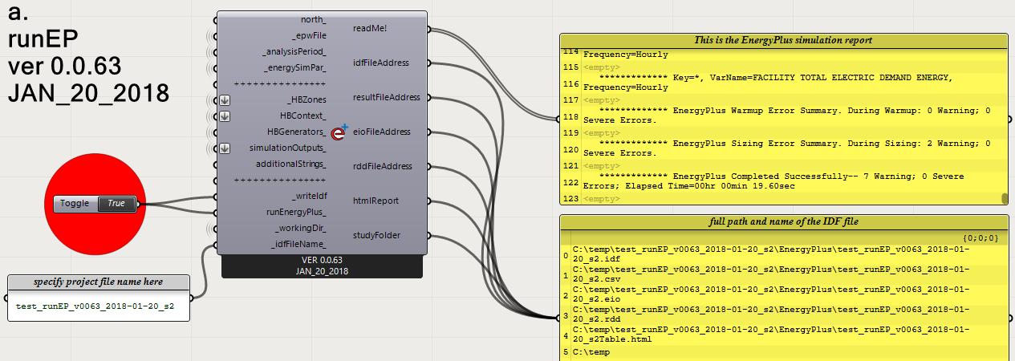
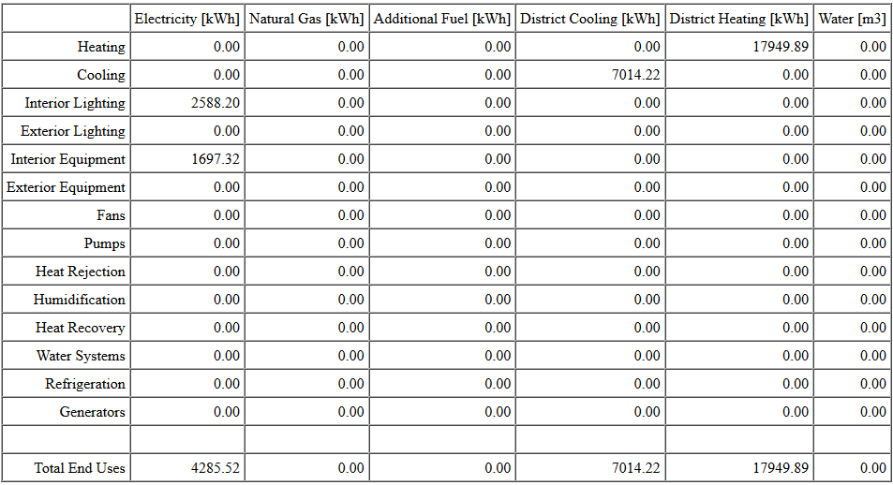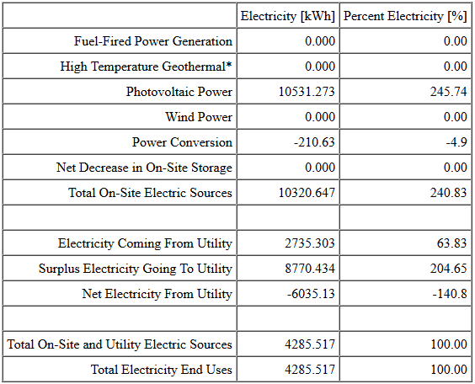
Scenario 3 (S3) : test_PVgen_s3.gh

PVgen component is replaced with the latest version.
Compatibility |  | Old |  | New
 |  | Ladybug  V0066  JUN-02-2018 | Honeybee  V0063  JAN-20-2018 | Ladybug  V0066  JUL-11-2018 | Honeybee  V0063  JUN-29-2018
Old | PVgen  V0063  JAN-20-2018 | Yes |  | Error  The length of a list of inputs is longer than the number of Honeybee surfaces connected to this component!
 | generationSystem  V0062  JUL-28-2017 | Yes
 | runEnergySimulation  V0063  JAN-20-2018 | Yes |  | Error  - Solution exception:'PV_gen' object has no attribute 'surfacename'
New | PVgen  V0063  MAR-08-2018 | Error  - Solution exception:__init__() takes exactly 12 arguments (8 given) |  | Error  - The length of a list of inputs is longer than the number of Honeybee surfaces connected to this component!
 | generationSystem  V0063  JAN-20-2018 | Yes |  | Yes
 | runEnergySimulation  v0063  JUL-24-2018 | No  (got reminder to update HB) |  | Error  - Solution exception:'PV_gen' object has no attribute 'surfacename'
 | exportToOpenStudio  V0063  AUG-08-2018 |  |  | Yes

Error:
Got the following error even if the input data for each of the input nodes has been changed to a list of values:
1. Solution exception:__init__() takes exactly 12 arguments (8 given)
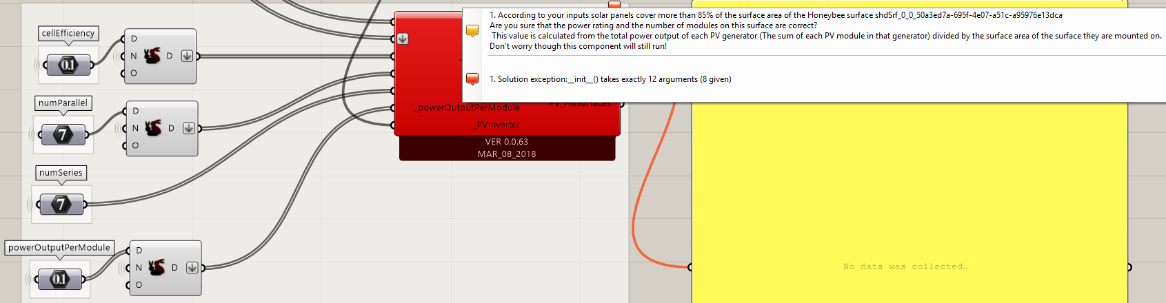

Unable to proceed to run the simulation.

Scenario 4 (S4) : test_PVgen_s4.gh

Old PVgen and generationSystem components were tested in new LB+HB
Compatibility |  | Old |  | New
 |  | Ladybug  V0066  JUN-02-2018 | Honeybee  V0063  JAN-20-2018 | Ladybug  V0066  JUL-11-2018 | Honeybee  V0063  JUN-29-2018
Old | PVgen  V0063  JAN-20-2018 | Yes |  | Error  The length of a list of inputs is longer than the number of Honeybee surfaces connected to this component!
 | generationSystem  V0062  JUL-28-2017 | Yes
 | runEnergySimulation  V0063  JAN-20-2018 | Yes |  | Error  - Solution exception:'PV_gen' object has no attribute 'surfacename'
New | PVgen  V0063  MAR-08-2018 | Error  - Solution exception:__init__() takes exactly 12 arguments (8 given) |  | Error  - The length of a list of inputs is longer than the number of Honeybee surfaces connected to this component!
 | generationSystem  V0063  JAN-20-2018 | Yes |  | Yes
 | runEnergySimulation  v0063  JUL-24-2018 | No  (got reminder to update HB) |  | Error  - Solution exception:'PV_gen' object has no attribute 'surfacename'
 | exportToOpenStudio  V0063  AUG-08-2018 |  |  | Yes

Error:
Got the following error on mismatching input lists, although all the inputs remain the same.
- The length of a list of inputs into either _name_, _cellsEfficiency, _integrationMode, _NoParallel,_Noseries, _costPVgen or _powerOutput is longer than the number of Honeybee surfaces connected to this component! e.g if you have 2 Honeybee surfaces you cannot have 3 values input into _costPVgen! Please check the inputs and try again!

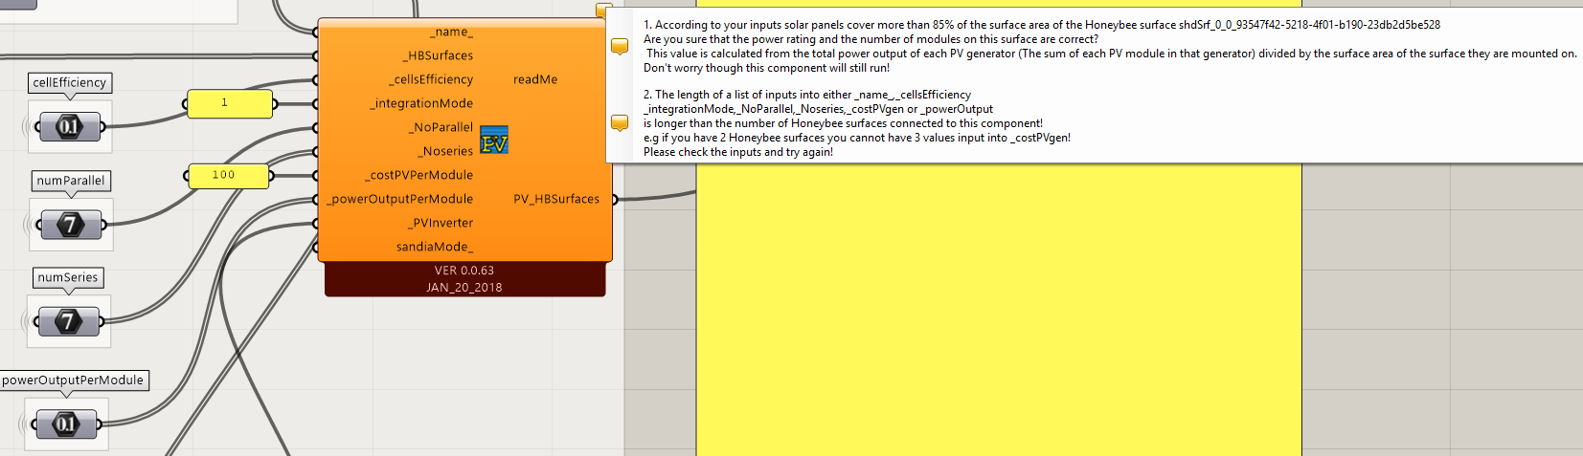

Unable to proceed to run the simulation.

Scenario 5 (S5) : test_PVgen_s5.gh

New PVgen and generationSystem components were used.
Compatibility |  | Old |  | New
 |  | Ladybug  V0066  JUN-02-2018 | Honeybee  V0063  JAN-20-2018 | Ladybug  V0066  JUL-11-2018 | Honeybee  V0063  JUN-29-2018
Old | PVgen  V0063  JAN-20-2018 | Yes |  | Error  - The length of a list of inputs is longer than the number of Honeybee surfaces connected to this component!
 | generationSystem  V0062  JUL-28-2017 | Yes
 | runEnergySimulation  V0063  JAN-20-2018 | Yes
New | PVgen  V0063  MAR-08-2018 | Error  - Solution exception:__init__() takes exactly 12 arguments (8 given) |  | Error  - The length of a list of inputs is longer than the number of Honeybee surfaces connected to this component!  - PV_HBSurfaces output is “-1”
 | generationSystem  V0063  JAN-20-2018 | Yes
 | runEnergySimulation  v0063  JUL-24-2018 | No  (got reminder to update HB)
exportToOpenStudio
V0063
AUG-08-2018

Error:
- Still have the input list length mismatching issue
- PV_HBSurfaces output is “-1”, although the PV generator definition seems to be OK.
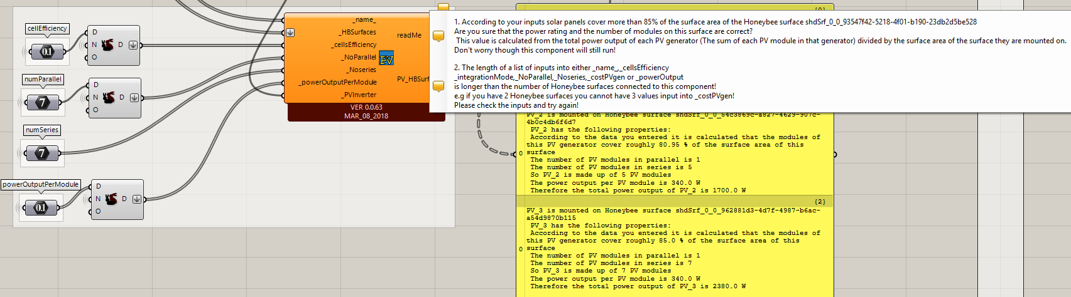
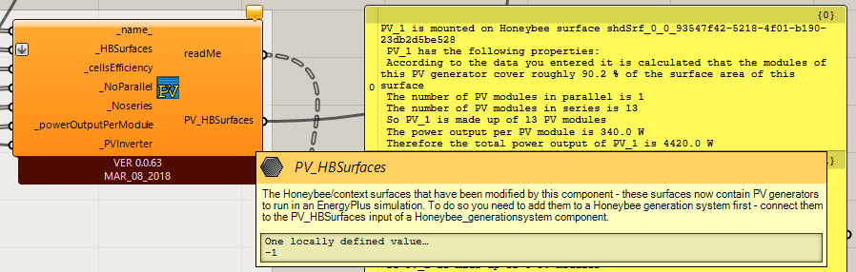
Scenario 6 (S6) : test_PVgen_s6.gh

The components used and the versions are the same as Scenario 5.
Compatibility |  | Old |  | New
 |  | Ladybug  V0066  JUN-02-2018 | Honeybee  V0063  JAN-20-2018 | Ladybug  V0066  JUL-11-2018 | Honeybee  V0063  JUN-29-2018
Old | PVgen  V0063  JAN-20-2018 | Yes |  | Error  - The length of a list of inputs is longer than the number of Honeybee surfaces connected to this component!
 | generationSystem  V0062  JUL-28-2017 | Yes
 | runEnergySimulation  V0063  JAN-20-2018 | Yes
New | PVgen  V0063  MAR-08-2018 | Error  - Solution exception:__init__() takes exactly 12 arguments (8 given) |  | Error  - The length of a list of inputs is longer than the number of Honeybee surfaces connected to this component!  - PV_HBSurfaces output is “-1”
 | generationSystem  V0063  JAN-20-2018 | Yes
 | runEnergySimulation  v0063  JUL-24-2018 | No  (got reminder to update HB)
exportToOpenStudio
V0063
AUG-08-2018

But line 443 and 458 of the code in PVgen component for the error return of “-1” were suppressed so that PV_HBSurfaces can output surfaces.
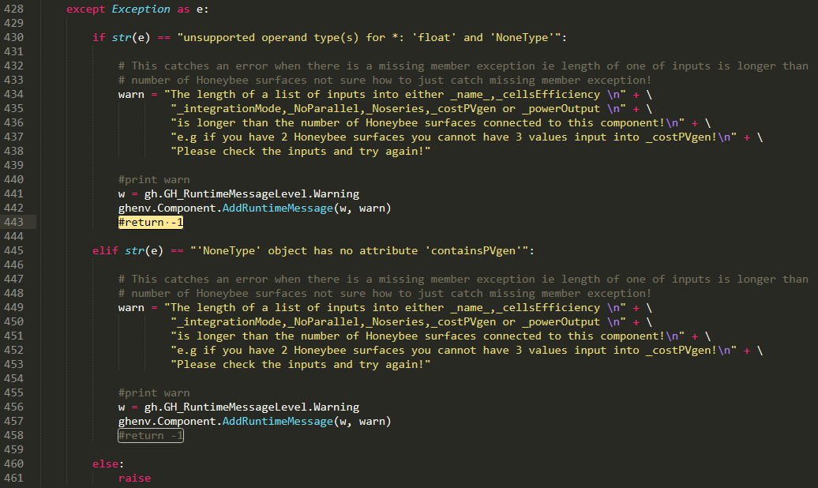

Error:
Although the three PV surfaces can be output from “PV_HBSurfaces” now, the following warning remains:

- The length of a list of inputs into either _name_, _cellsEfficiency, _integrationMode, _NoParallel,_Noseries, _costPVgen or _powerOutput is longer than the number of Honeybee surfaces connected to this component! e.g if you have 2 Honeybee surfaces you cannot have 3 values input into _costPVgen! Please check the inputs and try again!
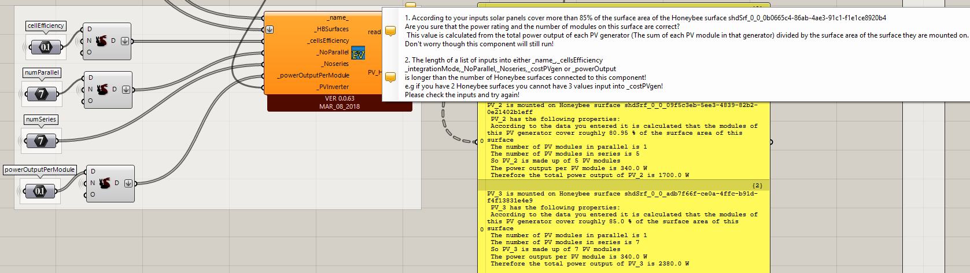

The code revision above doesn’t work with the old and new versions of runEnergySimulation components, and the following error is reported:

Solution exception:'PV_gen' object has no attribute 'surfacename'

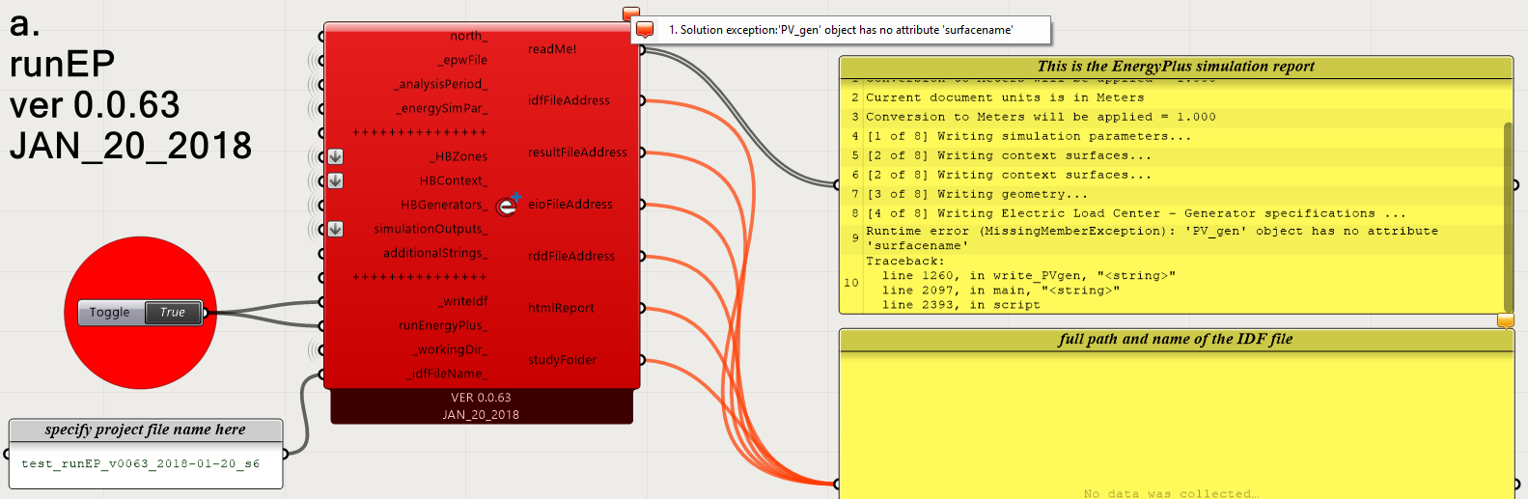

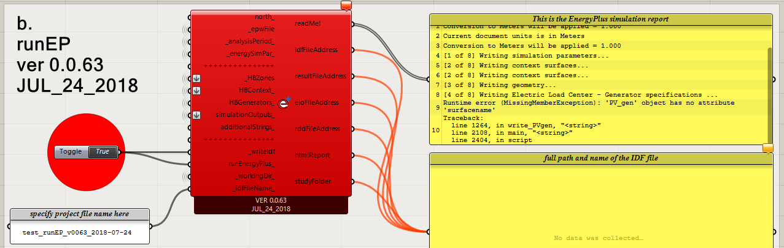
Scenario 7 (S7) : test_PVgen_s7.gh

Simulation was run by the exportToOpenStudio component
Compatibility |  | Old |  | New
 |  | Ladybug  V0066  JUN-02-2018 | Honeybee  V0063  JAN-20-2018 | Ladybug  V0066  JUL-11-2018 | Honeybee  V0063  JUN-29-2018
Old | PVgen  V0063  JAN-20-2018 | Yes |  | Error  The length of a list of inputs is longer than the number of Honeybee surfaces connected to this component!
 | generationSystem  V0062  JUL-28-2017 | Yes
 | runEnergySimulation  V0063  JAN-20-2018 | Yes |  | Error  - Solution exception:'PV_gen' object has no attribute 'surfacename'
New | PVgen  V0063  MAR-08-2018 | Error  - Solution exception:__init__() takes exactly 12 arguments (8 given) |  | Error  - The length of a list of inputs is longer than the number of Honeybee surfaces connected to this component!
 | generationSystem  V0063  JAN-20-2018 | Yes |  | Yes
 | runEnergySimulation  v0063  JUL-24-2018 | No  (got reminder to update HB) |  | Error  - Solution exception:'PV_gen' object has no attribute 'surfacename'
 | exportToOpenStudio  V0063  AUG-08-2018 |  |  | Yes

Simulation works
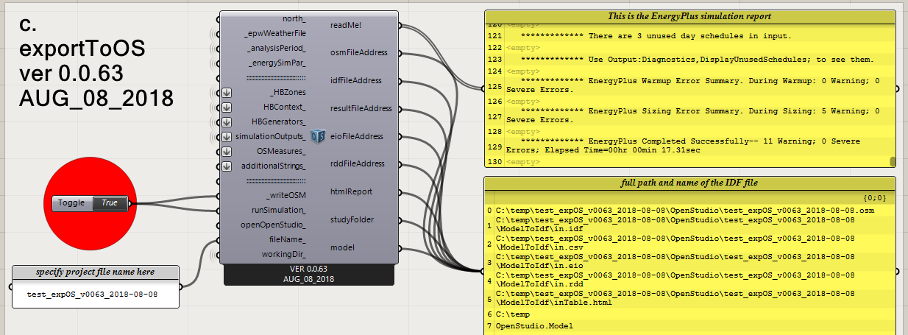

However, the PV electricity generation related output is not the same as the one generated using old versions of LB, HB, PVgen, generationSystem and runEnergySimulation components.

Result of Scenario 7 (in GJ)

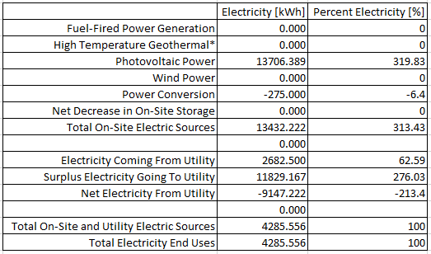
Result of Scenario 7 (in kWh) Result of S1 (in kWh)

Four output variables were also missing which were generated correctly in Scenario 1.
 | Electricity load and generation related output variables requested |  |  | Scenario
 |  |  |  | 1 | 2 | 3 | 4 | 5 | 6 | 7
1 | Electric Load Center Produced Electric Energy |  |  |  |  |  |  |  |  | X
2 | Electricity:Building |  |  |  |  |  |  |  |  | X
3 | ElectricityNet:Facility |  |  |  |  |  |  |  |  | X
4 | ElectricityPurchased:Facility |  |  |  |  |  |  |  |  | X
5 | Facility Net Purchased Electric Energy
6 | Facility Total Building Electric Demand Power
7 | Facility Total Electric Demand Power
8 | Facility Total HVAC Electric Demand Power
9 | Facility Total Produced Electric Energy
10 | Facility Total Purchased Electric Energy
11 | Facility Total Surplus Electric Energy
12 | Generator PV Array Efficiency
13 | Generator PV Cell Temperature |  |  | X | X |  |  |  |  | X
14 | Generator Produced DC Electric Energy
15 | Generator Produced DC Electric Power
 | Generated | Not generated | X : missing

